**Exercise 1: Configuring a Basic Spring Application**

**applicationContext.xml –**

<?xml version="1.0" encoding="UTF-8"?>  
<beans xmlns="http://www.springframework.org/schema/beans"  
 xmlns:xsi="http://www.w3.org/2001/XMLSchema-instance"  
 xsi:schemaLocation="  
 http://www.springframework.org/schema/beans  
 http://www.springframework.org/schema/beans/spring-beans.xsd">  
  
 <bean id="bookRepository" class="com.library.repository.BookRepository"/>  
  
 <bean id="bookService" class="com.library.service.BookService">  
 <property name="bookRepository" ref="bookRepository"/>  
 </bean>  
</beans>

**Created a package called com.library.repository within class named as BookRepository –**

package com.library.repository;  
  
public class BookRepository {  
 public void displayRepositoryInfo() {  
 System.*out*.println("Inside BookRepository: Handling database operations.");  
 }  
}

**Created a package called com.library.service within class named as BookService –**

package com.library.service;  
  
import com.library.repository.BookRepository;  
  
public class BookService {  
 private BookRepository bookRepository;  
  
 public void setBookRepository(BookRepository bookRepository) {  
 this.bookRepository = bookRepository;  
 }  
  
 public void displayServiceInfo() {  
 System.*out*.println("Inside BookService: Performing business logic.");  
 bookRepository.displayRepositoryInfo();  
 }  
}

**Created a package called com.library within class named as App –**

package com.library;  
  
import com.library.service.BookService;   
import org.springframework.context.ApplicationContext;  
import org.springframework.context.support.ClassPathXmlApplicationContext;  
  
public class App {  
 public static void main(String[] args) {  
 ApplicationContext context = new ClassPathXmlApplicationContext("applicationContext.xml");  
  
 BookService bookService = (BookService) context.getBean("bookService");  
  
 bookService.displayServiceInfo();  
 }  
}

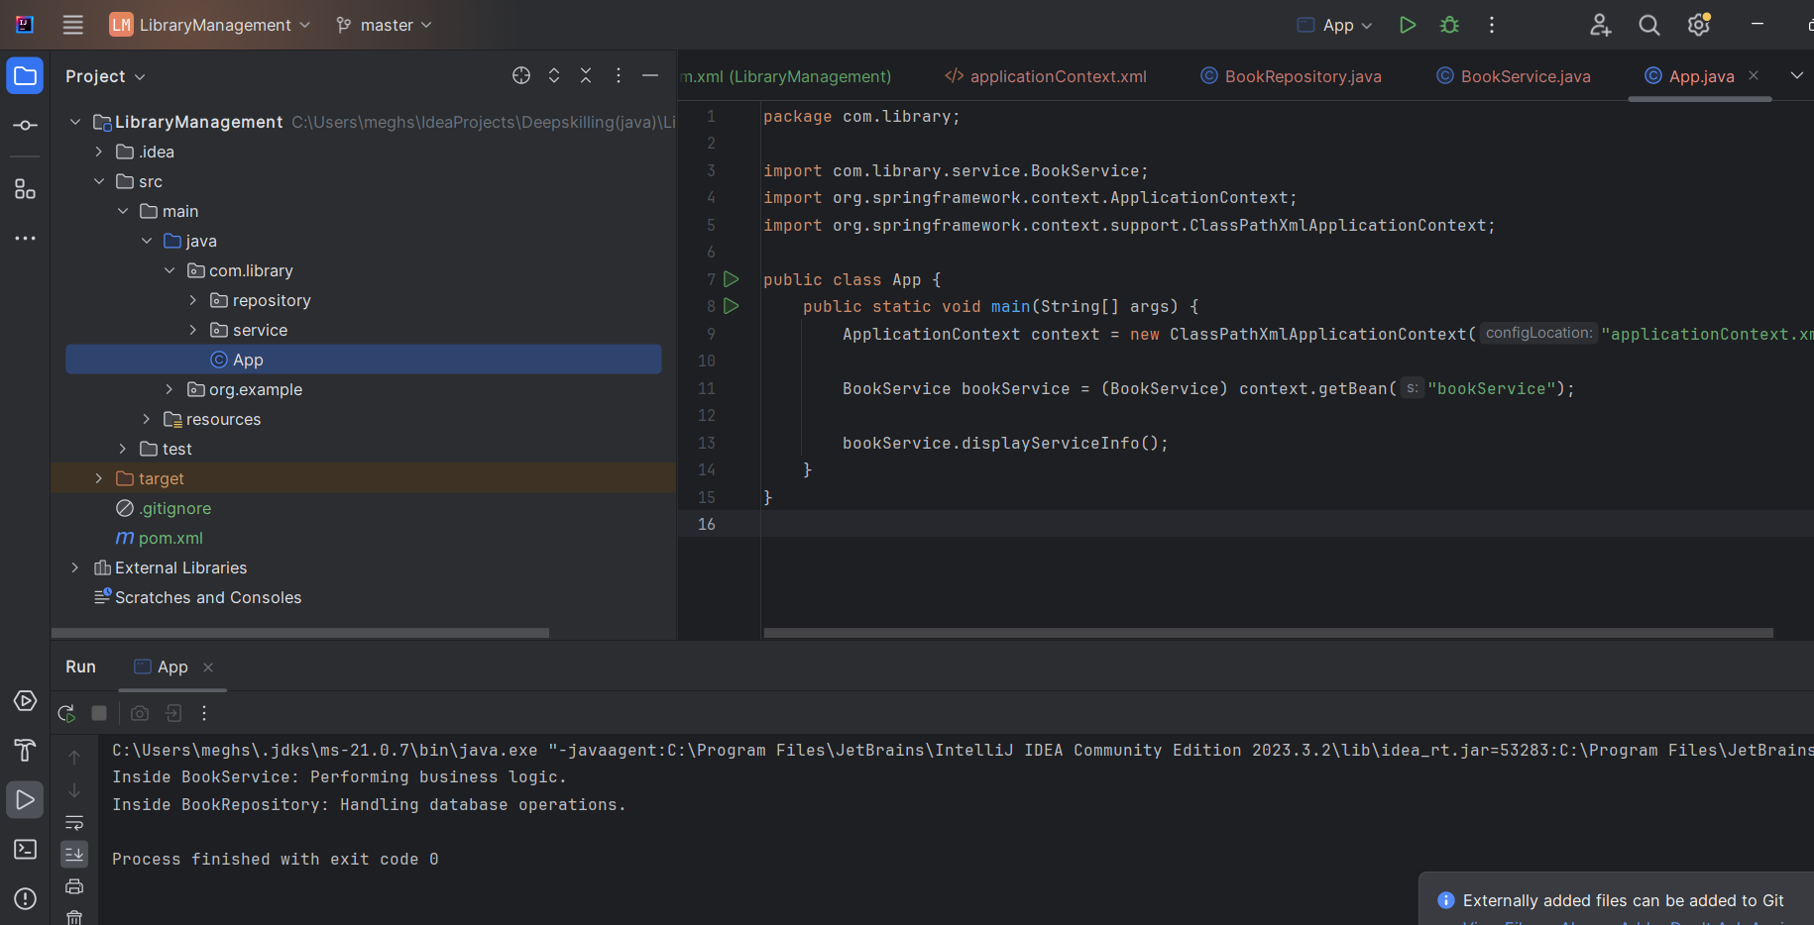

**Exercise 2: Implementing Dependency Injection**

**Updated the applicationContext.xml –**

<?xml version="1.0" encoding="UTF-8"?>  
<beans xmlns="http://www.springframework.org/schema/beans"  
 xmlns:xsi="http://www.w3.org/2001/XMLSchema-instance"  
 xsi:schemaLocation="  
 http://www.springframework.org/schema/beans  
 http://www.springframework.org/schema/beans/spring-beans.xsd">  
  
 <!-- BookRepository Bean -->  
 <bean id="bookRepository" class="com.library.repository.BookRepository"/>  
  
 <!-- BookService Bean with Dependency Injection -->  
 <bean id="bookService" class="com.library.service.BookService">  
 <property name="bookRepository" ref="bookRepository"/>  
 </bean>  
  
</beans>

**BookService.java –**

package com.library.service;  
  
import com.library.repository.BookRepository;  
  
public class BookService {  
 private BookRepository bookRepository;  
  
 // Setter method for Dependency Injection  
 public void setBookRepository(BookRepository bookRepository) {  
 this.bookRepository = bookRepository;  
 }  
  
 public void displayServiceInfo() {  
 System.*out*.println("Inside BookService: Performing business logic.");  
 bookRepository.displayRepositoryInfo();  
 }  
}

**BookRepository.java –**

package com.library.repository;  
  
public class BookRepository {  
 public void displayRepositoryInfo() {  
 System.*out*.println("Inside BookRepository: Handling database operations.");  
 }  
}

**App.java –**

package com.library;  
  
import com.library.service.BookService;  
import org.springframework.context.ApplicationContext;  
import org.springframework.context.support.ClassPathXmlApplicationContext;  
  
public class App {  
 public static void main(String[] args) {  
 // Load Spring ApplicationContext from XML  
 ApplicationContext context = new ClassPathXmlApplicationContext("applicationContext.xml");  
  
 // Get BookService bean  
 BookService bookService = (BookService) context.getBean("bookService");  
  
 // Call service method  
 bookService.displayServiceInfo();  
 }  
}

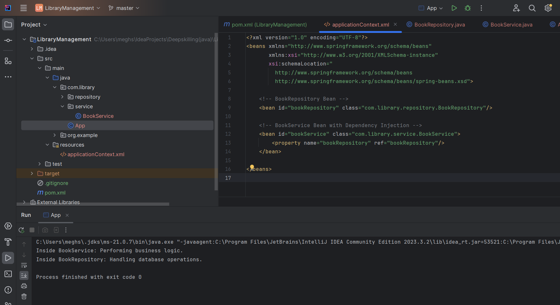

**Exercise 4: Creating and Configuring a Maven Project**

<project xmlns="http://maven.apache.org/POM/4.0.0"

xmlns:xsi="http://www.w3.org/2001/XMLSchema-instance"

xsi:schemaLocation="http://maven.apache.org/POM/4.0.0

https://maven.apache.org/xsd/maven-4.0.0.xsd">

<modelVersion>4.0.0</modelVersion>

<groupId>com.library</groupId>

<artifactId>LibraryManagement</artifactId>

<version>1.0-SNAPSHOT</version>

<properties>

<maven.compiler.source>1.8</maven.compiler.source>

<maven.compiler.target>1.8</maven.compiler.target>

</properties>

<dependencies>

<!-- Spring Context -->

<dependency>

<groupId>org.springframework</groupId>

<artifactId>spring-context</artifactId>

<version>5.3.36</version>

</dependency>

<!-- Spring AOP -->

<dependency>

<groupId>org.springframework</groupId>

<artifactId>spring-aop</artifactId>

<version>5.3.36</version>

</dependency>

<!-- Spring Web MVC -->

<dependency>

<groupId>org.springframework</groupId>

<artifactId>spring-webmvc</artifactId>

<version>5.3.36</version>

</dependency>

<!-- For Servlet API (required by Spring Web MVC) -->

<dependency>

<groupId>javax.servlet</groupId>

<artifactId>javax.servlet-api</artifactId>

<version>4.0.1</version>

<scope>provided</scope>

</dependency>

</dependencies>

<build>

<plugins>

<!-- Maven Compiler Plugin -->

<plugin>

<groupId>org.apache.maven.plugins</groupId>

<artifactId>maven-compiler-plugin</artifactId>

<version>3.10.1</version>

<configuration>

<source>1.8</source>

<target>1.8</target>

</configuration>

</plugin>

</plugins>

</build>

</project>

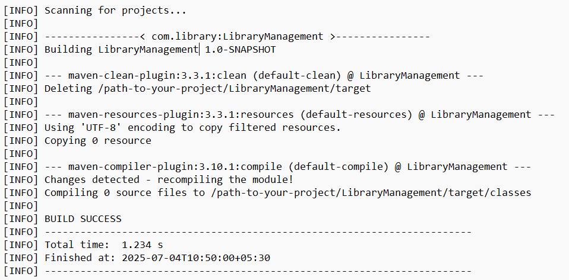

**Spring Data JPA - Quick Example**

Pom.xml

<dependencies>

<dependency>

<groupId>org.springframework.boot</groupId>

<artifactId>spring-boot-starter-data-jpa</artifactId>

</dependency>

<dependency>

<groupId>mysql</groupId>

<artifactId>mysql-connector-java</artifactId>

<scope>runtime</scope>

</dependency>

<dependency>

<groupId>org.springframework.boot</groupId>

<artifactId>spring-boot-starter</artifactId>

</dependency>

<dependency>

<groupId>org.springframework.boot</groupId>

<artifactId>spring-boot-devtools</artifactId>

<scope>runtime</scope>

</dependency>

</dependencies>

# Logs

logging.level.org.springframework=info

logging.level.com.cognizant=debug

logging.level.org.hibernate.SQL=trace

logging.level.org.hibernate.type.descriptor.sql=trace

# Console log format

logging.pattern.console=%d{dd-MM-yy} %d{HH:mm:ss.SSS} %-20.20thread %5p %-25.25logger{25} %25M %4L %m%n

# Database

spring.datasource.url=jdbc:mysql://localhost:3306/ormlearn

spring.datasource.username=root

spring.datasource.password=root

spring.datasource.driver-class-name=com.mysql.cj.jdbc.Driver

# Hibernate

spring.jpa.hibernate.ddl-auto=validate

spring.jpa.properties.hibernate.dialect=org.hibernate.dialect.MySQL5Dialect

**SQL Database-**

CREATE DATABASE IF NOT EXISTS ormlearn;

USE ormlearn;

CREATE TABLE country (

code VARCHAR(2) PRIMARY KEY,

name VARCHAR(50)

);

INSERT INTO country VALUES ('IN', 'India');

INSERT INTO country VALUES ('US', 'United States of America');

**Country.java**

package com.cognizant.ormlearn.model;

import javax.persistence.Column;

import javax.persistence.Entity;

import javax.persistence.Id;

import javax.persistence.Table;

@Entity

@Table(name="country")

public class Country {

@Id

@Column(name="code")

private String code;

@Column(name="name")

private String name;

public String getCode() { return code; }

public void setCode(String code) { this.code = code; }

public String getName() { return name; }

public void setName(String name) { this.name = name; }

@Override

public String toString() {

return "Country [code=" + code + ", name=" + name + "]";

}

}

package com.cognizant.ormlearn.repository;

import org.springframework.data.jpa.repository.JpaRepository;

import org.springframework.stereotype.Repository;

import com.cognizant.ormlearn.model.Country;

@Repository

public interface CountryRepository extends JpaRepository<Country, String> {

}

package com.cognizant.ormlearn.service;

import java.util.List;

import javax.transaction.Transactional;

import org.springframework.beans.factory.annotation.Autowired;

import org.springframework.stereotype.Service;

import com.cognizant.ormlearn.model.Country;

import com.cognizant.ormlearn.repository.CountryRepository;

@Service

public class CountryService {

@Autowired

private CountryRepository countryRepository;

@Transactional

public List<Country> getAllCountries() {

return countryRepository.findAll();

}

}

package com.cognizant.ormlearn;

import java.util.List;

import org.slf4j.Logger;

import org.slf4j.LoggerFactory;

import org.springframework.boot.SpringApplication;

import org.springframework.boot.autoconfigure.SpringBootApplication;

import org.springframework.context.ApplicationContext;

import com.cognizant.ormlearn.model.Country;

import com.cognizant.ormlearn.service.CountryService;

@SpringBootApplication

public class OrmLearnApplication {

private static final Logger LOGGER = LoggerFactory.getLogger(OrmLearnApplication.class);

private static CountryService countryService;

public static void main(String[] args) {

ApplicationContext context = SpringApplication.run(OrmLearnApplication.class, args);

LOGGER.info("Inside main");

countryService = context.getBean(CountryService.class);

testGetAllCountries();

}

private static void testGetAllCountries() {

LOGGER.info("Start");

List<Country> countries = countryService.getAllCountries();

LOGGER.debug("countries={}", countries);

LOGGER.info("End");

}

}



**Hands on 4**

**Difference between JPA, Hibernate and Spring Data JPA**

| **Aspect** | **JPA (Java Persistence API)** | **Hibernate** | **Spring Data JPA** |
| --- | --- | --- | --- |
| Type | Specification (Interface-based standard) | Implementation (ORM tool and JPA provider) | Framework abstraction over JPA implementations like Hibernate |
| Who defines it | Oracle (JSR 338) | Red Hat | Spring Framework Team |
| Purpose | Provides a standard for ORM in Java applications | Implements JPA and adds extra ORM capabilities | Simplifies JPA usage by removing boilerplate repository code |
| Contains Implementation | No | Yes | No, relies on existing JPA provider |
| Transaction Management | Depends on implementation | Available through Hibernate APIs | Managed declaratively using Spring’s @Transactional |
| Code Boilerplate | More compared to Spring Data JPA | Less than plain JDBC, but still requires session management | Minimal, CRUD handled by extending JpaRepository |
| Query Language | JPQL (Java Persistence Query Language) | HQL (Hibernate Query Language, similar to JPQL with extras) | JPQL, derived queries, native queries, and query methods |
| Example Use | Defines @Entity, @Id, @Column annotations | Uses SessionFactory, Session, Transaction objects | Extends JpaRepository interface and uses autowired services |